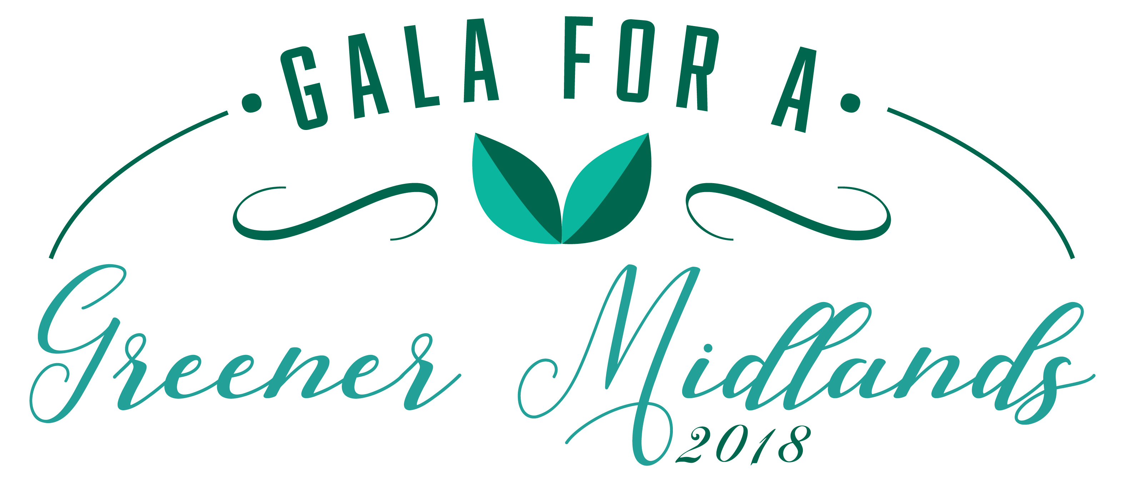
Keep the Midlands Beautiful will be hosting the 7th annual Gala for a Greener Midlands on November 16th, 2018 at the River Center at Saluda Shoals. KMB would appreciate your support as an event sponsor. The money raised from the Gala will go towards forwarding the Mission of Keep the Midlands Beautiful and primarily, beautification projects in the Midlands. This year we have partnered with Farm2Table for a delicious meal and a fun and festive event. Please join us and help to make this evening a night to remember.

We have four levels of sponsorship you can choose from.
- Signature Sponsor is the Event sponsor. Sponsors name will have top billing on all banners, signage, and program’s, menu’s and will be mentioned by the MC throughout the evening. Signature Sponsor will also be entitled to up to 2 tables 16 tickets. Also, you receive all that is provided to all other sponsorship levels: $5,000

- Platinum level sponsor for a $1,25000.00 entitles you to 8 tickets, a bottle of champagne and commemorative gifts on your table. Your logo will also be included on all digital signs, table sign and listed in table program.

- Gold level sponsor for $1000 entitles you to 6 tickets, commemorative gifts on your table, your logo on the digital signs, table card and listed in table program.

- Silver level sponsor for $600 entitles 4 tickets, your name on the digital sign, table card and business listed in table program.

Your generous donation will help us fund beautification projects in the Midlands. Keep the Midlands Beautiful has partnered with many organizations to extend our funds over the last year and we plan to do the same this year.

Keep the Midlands Beautiful office location was destroyed this past year; we continued to push on and supported all our core programs. We are slowly replacing our contents and supplies. This fundraiser is our “main event” please help us make it a success

If you are not able to sponsor a table please consider purchasing tickets for the evening. Tickets are $100 per person.

We could not do this without the generous support of a caring community. Thank you again for your commitment to the “Gala for a Greener Midlands” and helping to Keep the Midlands Beautiful.

Sincerely,

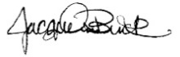

Jacqueline Buck
Executive Director

