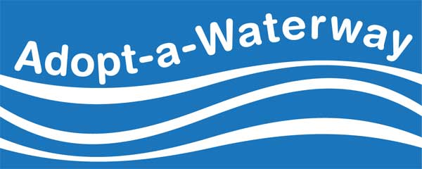
Return to:
Keep the Midlands Beautiful
Attn: Adopt-A-Waterway
1305 Augusta Road
West Columbia, SC 29169
□ New agreement
□ Renewal Agreement

Agreement Form

Part 1: Contact Information

Group Name: __________________________________________________________________________________

Group Leader Name: ____________________________________________________________________________

Group Leader Mailing Address: ____________________________________________________________________

______________________________________________________________________________________________

Group Leader Daytime Phone: ____________________________________________________________________

Group Leader E-mail: ___________________________________________________________________________

Alternate Group Contact Name: __________________________________________________________________

Alternate Group Contact Phone / E-mail: ___________________________________________________________

Part 2: Agreement — PLEASE READ CAREFULLY

This Adoption Agreement is made between Keep the Midlands Beautiful’s Adopt-A-Waterway Program ("Program") and _________________________________________________________ ("Adopting Group").
Group Name

Keep the Midlands Beautiful recognizes the Adopting Group as the adopting organization for

Waterway Name

The Adopting Group’s volunteers accept the responsibility for picking up litter along the above section of waterway at least 2 times a year for a period of two (2) years beginning ____________________ 20_____ and ending __________________________ 20_____.

All parties hereby agree to the following terms governing this Agreement:

I. The Program's Obligations

As consideration for the Adopting Group's agreement to perform obligations under this Agreement, the Program hereby agrees to:
- Provide garbage bags.
- Advise on land ownership surrounding adopted waterway.
- Advise on proper disposal of trash.
- Provide the group leader with an orientation and training session.
- Provide safety instructions.
- Provide public recognition of adoption.
II. The Adopting Group's Obligations

The Adopting Group hereby agrees to:
- Act and serve as the voluntary caretaker for your stretch of waterway.
- Perform cleanup project activities for adopted waterway and report on your projects at least two times per year during the two-year duration of this Agreement.
- Read and review this Agreement and the Safety Guidelines before all cleanup project activities. The Adopting Group further agrees all cleanup project participants shall follow all procedures and safety instructions outlined in this Agreement and the Safety Guidelines.
- Require all cleanup project participants to review, complete and sign the Volunteer Participation and Waiver Form prior to participation in any cleanup project activities. The Adopting Group further agrees all cleanup project participants under the age of eighteen (18) shall have a parent or legal guardian review, complete and sign the Volunteer Participation and Waiver Agreement on the minor participant's behalf. The Adopting Group further agrees to prohibit any person's participation in cleanup project activities without proper review and completion of the Volunteer Participation and Waiver Agreement.
- Provide adequate adult supervision for all minor cleanup project participants under the age of eighteen (18).
- Require all cleanup project participants traveling by boat or other watercraft to wear a properly fitted and sized U.S. Coast Guard-approved personal floatation device (Type I, II or III).
- Prohibit performance of any cleanup project activities under hazardous conditions including, but not limited to, thunderstorms, high water, floods, fog or darkness.
- Dispose of all collected trash and litter in a legal and responsible manner.
- Complete and submit an Adopt-A-Waterway Report Card within two weeks after each cleanup project. This can be done online at http://www.keepthemidlandsbeautiful.org/report-card-form.
- Assume and accept full responsibility for all risks arising from or related to cleanup project activities. The Adopting Group further agrees to waive all claims arising from or related to cleanup project activities. The Adopting Group further agrees all cleanup project sponsors, public and private landowners, Dominion Energy, Keep the Midlands Beautiful, and all their sponsors, supporters, directors, volunteers, representatives and agents shall be held harmless against all claims arising from or related to cleanup project activities. The Adopting Group further agrees this Agreement shall act as a complete bar against all actions or claims arising from or related to cleanup project activities. The Adopting Group further agrees that if any action or claim is made, this Adoption Agreement shall warrant immediate and final dismissal of all such actions or claims.

By my signature, I agree to all terms outlined above.

Group Leader Signature: _____________________________________________________________________

Group Leader Name (Printed): ________________________________________________________________

Date: _______________________________________

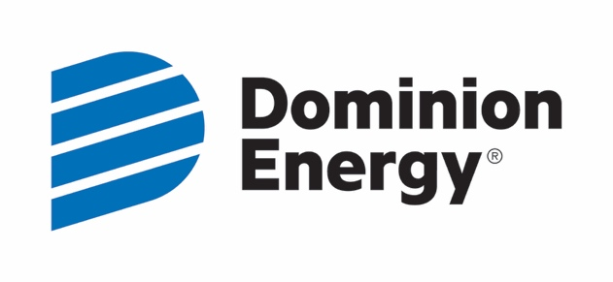
Coordinated by: Sponsored by:

